Game Design Document
(GDD)

111 424 111

written by Johannes Lange

Table of Contents
Contents
Table of Contents 2
1. Game Overview 3
1.1. Game Concept 3
1.2. Game loop 3
1.3. Vision Statement 4
2. Mechanics 5
2.1. Gameplay 5
2.2. Abilities 5
3. Level Design 6
4. Narrative 6
4.1. Player Character 6
4.2. Non-Player Characters 7
4.3. Plot 7
5. Interface 8
5.1. Controls: Mouse & Keyboard 8
5.2. Music, sound effects, audio 8
5.3. UI 8
● Start Menu 8
● Settings Menu 8
● HUD 8
6. Technical 8
6.1. Target Hardware: PC 8
6.2. Engine: Unreal Engine 5.5.4. 8
7. Art 8

1. Game Overview

1.1. Game Concept
- 3D Dream-core Puzzle Game
- The player characters hands change their appearance, and along with that their abilities
- They gain these mechanics by finding them and completing an event to have access to them for the remainder of the Game
- Use those abilities to progress through the levels to get to your goal
- The Goal: Wake Up!

1.2. Game loop
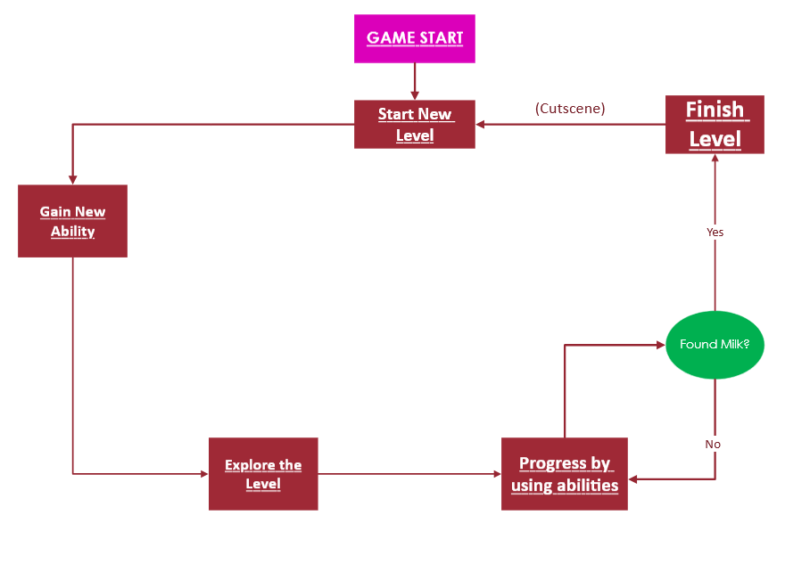

1.3. Vision Statement
What is the first question anyone asks themselves once they think about fiction?
Well, usually its “the Main character has been dreaming the entire story”.
With our Game, we want to ask the follow up question:
Why are they dreaming? What are they dreaming about? Who do the other characters in the dream represent?
111 424 111 is therefore a story set within a dream, about the dream, and everything it represents.

2. Mechanics

2.1. Gameplay
2.1.1. Sanity
Any time the Player encounters anything that breaks reality, too much for a normal person to handle it, their Sanity meter decreases.
This can be a fearsome monster, a Dialogue that is maddening, or even finding one of the MacGuffins.
If the player’s Sanity bar reaches zero at any point during gameplay, their mind breaks, they fall unconscious, and they respawn at the last checkpoint.

2.1.2. “MacGuffins”
The Objects that the player needs to collect in order to finish the Game.
They are placed at the end of each level, and upon collecting them the player will finish said level, moving on to the next one.
They are the player's way of progressing through the game properly, and the player will need to use the abilities they gain to find them, in conjunction with another.

2.1.3 . Closed doors
The final location features the doors that are inaccessible until the player finds the relative key to be able to open it.

2.1.4. Disappearing platforms
In an unreleased level there was a mechanic with a platforms that were disappearing short after they’ve been stepped on, and reappearing after some time in case the player fails from the first time.

2.2. Abilities
2.2.1. Enhanced Physicality
- Double Jump
- Works with an Endurance meter
- Jump N’ Run style puzzles
- Associated Color: RED

2.2.2. Astral Projection
- Being able to phase through walls
- Labyrinths with Hidden Pathways/Doors
- Associated Color: GREEN

2.2.3. Telekinesis
- Pulling specific Objects to them from a distance
- Pushing specific held objects away from them
- Placing Platforms in the air to walk on
- Object based Puzzles, Portal-esque
- Associated Color: BLUE

3. Level Design
Each of these levels are separate from each other, and are connected linearly. These levels have mechanics that are associated with them, and you will be able to use them to solve puzzles in order to progress to the end.
The first main level is the physical level. By using your enhanced speed and double jump, you are able to complete a Jump N’ Run puzzle in order to get to your daily objective and complete the “Day” properly.
The Second main level is all about Telekinesis, but it also works with both that and the Double Jump.
The Third main Level is the Spiritual level, where you gain Astral Projection, which you will then need to use in the level after it.
In the end, you reach the Hospital level, where you will be able to choose your preferred ending.
There are also multiple “Backroom” levels, to which there are entrances hidden throughout the other levels, offering secret content for the player to find and explore.
Build Backroom 1 and 2 We thought of making the players utilize the powers they had to their fullest and make it fun. The first level was intended to be played multiple times and allow the players to explore a small map with several paths between point A and point B. A door-opening sequence was also added to improve the atmosphere. In the case of the second level, we concentrated on randomness and the feeling of scariness. We put trigger points that once triggered the player is chased by a monster. This provides the tension and compels the players to make fast decisions during the parkouring of the level. During the parkouring and "puzzle" section of the level, where you need to rapidly switch to astral projection to go through the wall.
The hospital level initially was the resident evil/silent hill type location, with many closed doors and mini quests needed to be completed to open those doors and progress through the level. It got iterated afterwards, though the overall structure of the building remained. A player still needs to find a key for the chosen path, left or right corridor.

4. Narrative

4.1. Player Character
Since the game will take place in an extended dream sequence, the PC will be two distinct characters, the dream version being based on the hidden story of the reality version.
The Dream sequence will also be presented as an extension of the PC’s reality, which is amplified through the absurdity of their subconscious mind.
4.1.1. Dream version:
- Blank Slate
- Takes on the colours of the abilities they acquire
- Has no real idea where they are, and what they are trying to accomplish
- Will explore these questions through exploring the Game
- Trying to piece together what is going on and what happened to put them into this place

4.1.2. Reality Version:
- Student at the tail end of studying their degree
- They are suffering from extreme Insomnia
- Before the events of the game, they were awake for 100+ hours
- Staying awake for that long caused their brain to short circuit and induce a coma-esque state
- The dream sequence is where their subconscious places them into
- All their thoughts and emotions during this period are what creates the landscape and characters they encounter in the dream
- And their dream self is trying to find the way back to their body in the

4.2. Non-Player Characters
- Personifications of their fears, hopes, and other impactful things or situations they envisioned during their state of Insomnia
  - Meaning that their appearance can vary widely from fantastical to the mundane
- These can vary vastly between positive and negative attitudes towards the PC
- You will interact with them (and thus ideally piece together the story of the game) through dialogue

4.3. Plot
The Game’s story starts from the endpoint of the experience the Reality PC went through, as the player must piece together the information, which they receive by exploring the game and talking to the things, creatures, beings and people they encounter.
They start out knowing nothing about the situation they find themselves in, much like the player, and will have to figure this out as they go along.
Each step they take is a new piece of information that will lead them to the conclusion of the puzzle-like structure of the narrative.

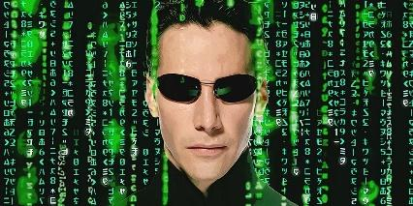
The first half of said conclusion is the dream version of the PC realising that they are dreaming.
To reach the true conclusion however, that being waking up, they will have to learn what caused this endless dream to happen and figure out how to fix that problem, which will be done by dealing with their reality, fixing their personal issues, confronting the struggles and mental health issues that caused them, instead of avoiding it by continuing to live in the fantasy of the dreamland.

5. Interface

5.1. Controls: Mouse & Keyboard

5.2. Music, sound effects, audio

5.3. UI

All elements were done in the same style to enhance the weirdcore atmosphere:

Start Menu

Settings Menu
- Skill Menu

HUD
  - Sanity Bar
  - Time
  - Endurance Meter
- Credits

6. Technical

6.1. Target Hardware: PC

6.2. Engine: Unreal Engine 5.5.4.

7. Art
- Low-poly dream-core 3D assets
- Liminal Spaces
- “Weird Guys” as NPCs (2D sprites)
- Progressively more unnerving with each day of the game
- Intentional Style Clashes all over the place in both 2D and 3D art, to break “reality” so to speak

