Fictional New Orleans
- New Orleans was known as “The Liquor Capital of America” during the Prohibition
- To put it simply, the people of New Orleans loved drinking alcohol a lot, notably even before the Prohibition
- So naturally, they were not going to stop making, drinking, and selling Alcohol just because some Government officials want them too
- The people started smuggling liquor and manufacturing their own alcohol in the comfort of their own homes almost immediately after the Prohibition Acts were made Law and put into effect
- An estimated 10 000 homes of New Orleans were said to have already broken the Prohibition Law by 1920
- The consumption and manufacture of Liquor in the Crescent City became sort of an open secret:
  - a wink to the right bartender if you were “known to the ‘House’” would get you a drink,
  - “Soft drink stands” sold beer to poorer people,
  - and of course, more VIP speakeasies were available to trusted customers throughout the whole city
- “The home of Jazz” would make for a very fitting and fun soundtrack for our game to focus around, making it work together with the general setting and vibes of the time
- New Orleans is breathtakingly beautiful due to the gigantic mix of different cultures
- Just like it’s still the case today, New Orleans had a very extravagant and hedonistic night-life even back then

Enforcing the Prohibiton:
- Governor of Luisiana was once asked about how he was going to enforce the Prohibition and what he was going to do, to which he answered: “Not a damn thing.”
- Prohibition enforcers (federal agents) had neither the means nor enough agents in their forces to be able to even stand a chance at shutting down even a fraction of the organized crime going on
- But they still tried shutting down as many speakeasies, supply houses, stills (distilleries), big breweries, clubs, restaurants, cabarets, and bars, by regularly raiding these establishments
- These raids became commonplace and a part of life for New Orleans, and there were multiple large and noteworthy raids that we can use as reference for possibly implementing into our game
- And on top of that the local law enforcement had no real desire to enforce Prohibition, as the police themselves enjoyed the vices of alcohol and the “criminal” nightlife, as well as the steady payments from being bribed

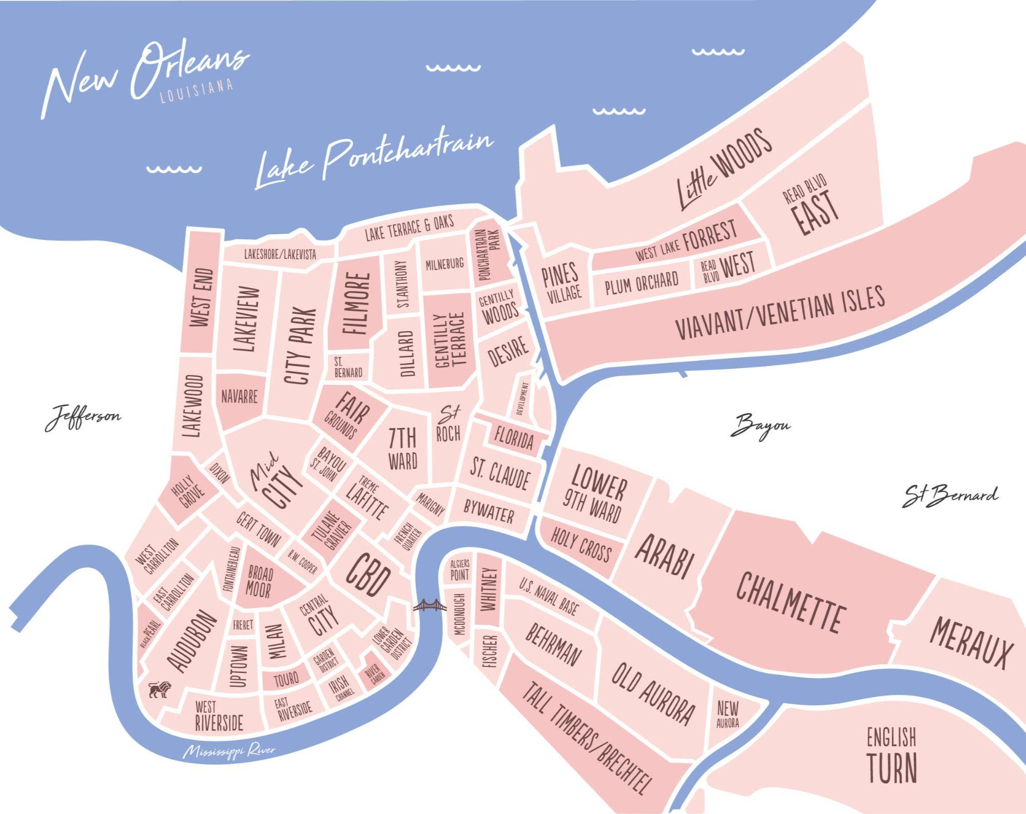
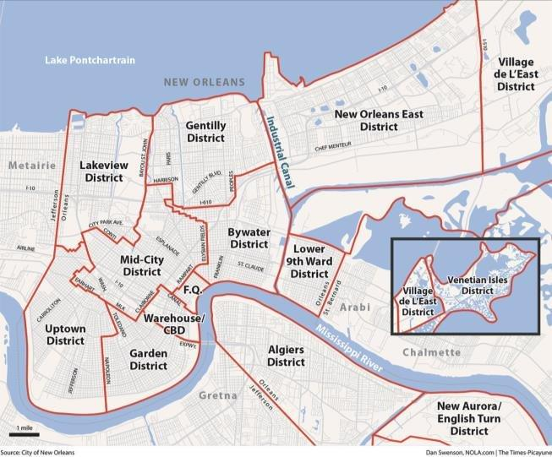
Maps:

