Science Wizard

General Info: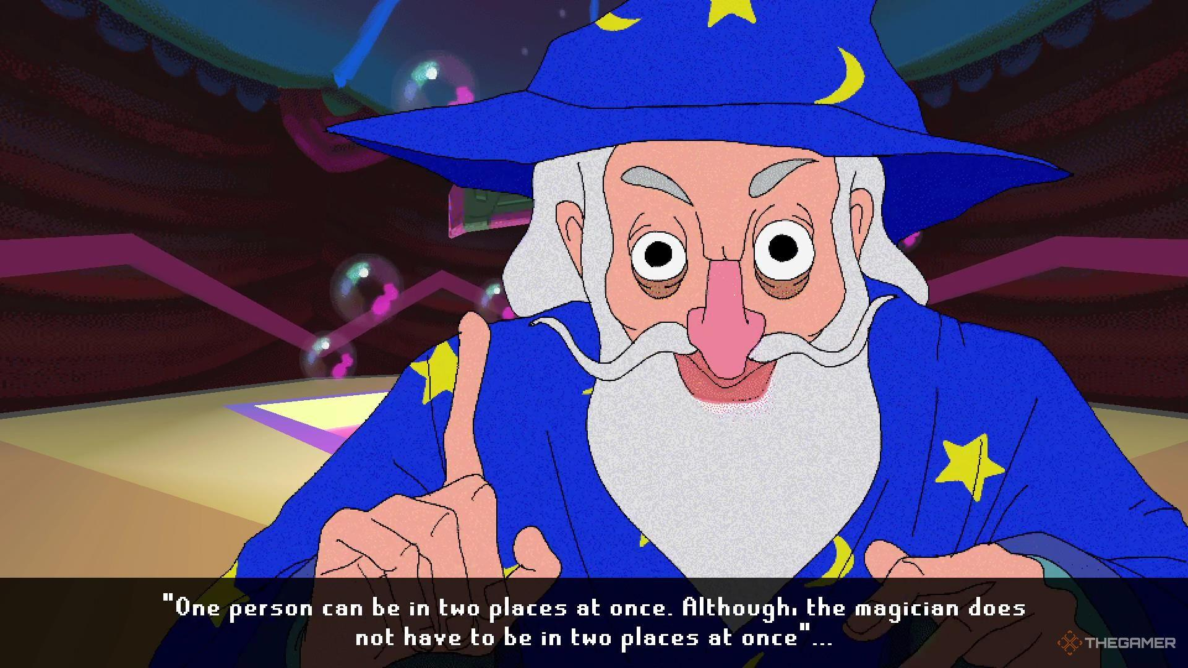
- Actual Character Name: Scientist of the Walls
- An old man studying the flora of his lawn, walls, and the windows in the city.
- Ancient old man. 200? Maybe? You don’t know.
- Very esoteric, but he starts off grounded and curious.
- He will slowly go insane.
- He will turn into one of the Weird Guys™️
- He’s going to be a wealth of knowledge of the world, but he will be less useful and understandable as time goes on and he turns into a rambling mess.
- Devil’s Train by The Lab Rats (song reference)
Wants:
- He wants to research and experiment with the Flora and Fauna found in the environment.
- He sees the player as a confident witness and an interesting person to discuss his theories with.
- HE NEEDS TO STUDY THE ENTIRE ENVIRONMENT
- HE NEEDS TO GET TO THE BOTTOM OF THIS
- He wants to discover the secret that he swears lies at the core of this place.

Fears:
- Being unable to complete his research is his greatest fear.
- They fear the people that are out to get him and to stop his research that he swears are following him. (Day 2)
- His fear and the pressure of his research is what will drive him insane, and what will start the transformation of his body into the surreal.
Needs:
- People aid him with his research, because one man cannot find the solution to this secret all by himself.
- Grounding him and getting him back to the ground when he gets too esoteric or crazy

Backstory:
- He started out as a regular scientist that was tasked to research the plants of this place.
- However, with each passing day of research he discovered that something was deeply wrong with this place
- Being a scientist, he knew that it was his duty to get to the bottom of this, and he happily started doing so, due to how interesting and curious this situation seems.
- His scientific nature will make him unable to stop his research, to the detriment of his own sanity and health.
- He feels tremendously lucky however, that he was the one who discovered this first. This is his research. This will be what cements him as one of the greats.
- The player character will find him on Day 1 of the game, when he still seems normal, content, and like a competent professor and scientist.

