Hooligans

General Info: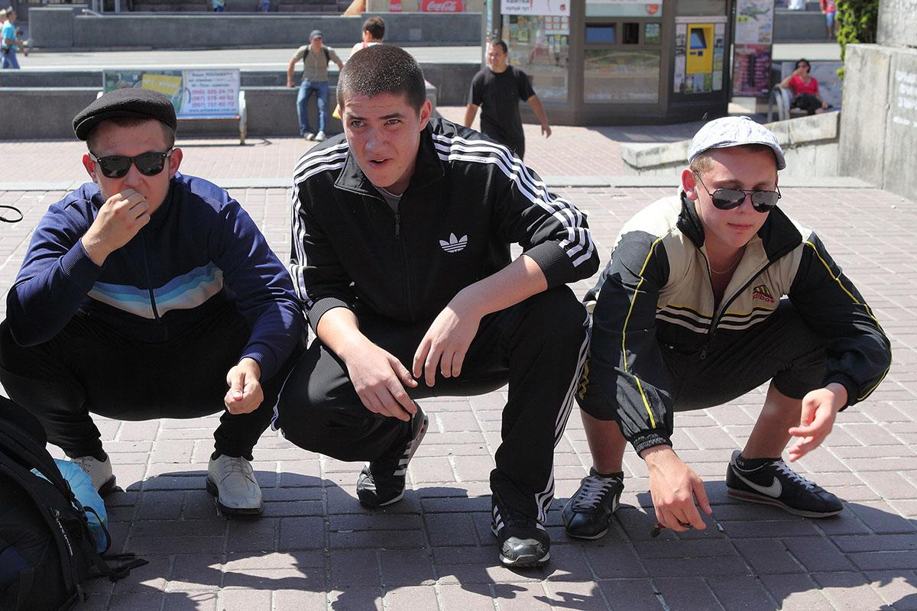
- Actual Character Name: Gopnik 1, 2, 3
- A group of annoying hooligans the Player will have to deal with or avoid
- Young guys, in their early 20s
- Imagine Toxic Masculinity meets substance abuse
- Talking to them should be an annoyance or an obstacle for the player
- They won’t give up information about the quest easily, but one of them, the sensitive one, can be persuaded to let you know the location of the shop
- The First Guy is the Leader and loud mouth of the group, he tells the others what to do, and they listen to him.
- The Second Guy is the Yes-Man to the leader, very spineless but it feels like there is more of an emotional connection? He will do whatever the Leader says however.
- The Third Guy is much more sensitive and less of a problem than the others.
It should feel like there is a hidden kind, and good heart, that he hides because he wants to support his friends.

Wants:
- They want to enjoy each others company, and cause as much mayhem and mischief as possible. Hedonism is God!
- They want to annoy the player character, because they do not like him for some reason, and will bully him.
- They want to party everywhere, all of the time, and they don’t care who gets in their way.
Fears:
- Losing each other and being alone.
- They both fear and respect their leader, and the leader fears losing his gang.
- They react insecurely and aggressively towards being challenged.
Needs:
- You can make their day by bringing them alcohol.
- They won’t respect you if you suck up to them, but they will respect you if you stand up to them.
- They also appreciate being able to take one of their awful jokes.

Backstory:
- This street is all they’ve ever known.
- They grew up living on this street, and only their life as a group managed to keep them safe, especially from people who sought to cause them harm or split them up.
- They have become very defensive because of this, and it has shaped their anti-authoritarian and rebellious nature.
- Nowadays, they reject society, and live their life together.
- They feel resentment towards society, for forgetting about them, so they will make everyone who meets them remember who they are.
- And you will find them between your apartment and in front of the store, standing in your way.

