Eternal Quest
Game Design Document
(GDD)

Table of Contents
1. Game Overview 4
1.1. Summary/Pitch 4
1.2. Inspirations 4
1.3. Player Experience 4
1.4. Platform 5
1.5. Software 5
1.6. Genre 5
1.7. Target Audience 5
2. Concept 6
2.1. Core Game loop 6
2.2. Combat 6
2.2.1. Hero Phase: 6
2.2.1. Enemy Phase: 7
2.2.1. Loot Phase: 8
2.2. Cards 9
2.2.1 Utility cards (UTC Cards) 9
2.2.1.1. Utility Card Slots 9
2.2.2. Action Cards (ACT Cards) 10
2.4. Proficiencies 11
2.4.1. Martial 11
2.4.2. Magical 11
2.4.2. Supporter 11
2.5. Enemies 11
2.5.2 . Regular Enemies 11
2.5.1. Boss Enemies 12
2.6. Level Design 12
2.6.1. Waves 12
2.6.2. Layers (TBA) 12
2.6.3. Dungeon 13
2.7. Narrative 13
2.7.1. Narrator 13
3. Interface 15
3.1. Controls 15
3.2. UI/UX 15
3.3. Menus 15
3.3.1. Start Menu 15
3.3.2. Settings Menu 15
3.3.3. HUD 15
3.3.4. Credits 15
4. Art Direction 16
4.1. Design 16
4.1.1. Artstyle 16
4.1.2. Concept art 16
4.1.3. Character designs 16
4.1.4. Environment 16
4.2. Visual Effects (VFX) 16
4.3. Lighting 16
4.4. Animation 16
5. Audio 16
5.1. Music 16
5.2. SFX 16

1. Game Overview

1.1. Summary/Pitch
Eternal Quest is a CO-OP deck building game in which two adventurers, represented by the players, enter an endless dungeon and start fighting their way through it. While encountering stronger enemies with each step, they must use their limited power and skill to fight them strategically to survive.

1.2. Inspirations
- Dungeons & Dragons
- That one Harry Potter card game
- That one Star Wars deck building Game

1.3. Player Experience
- The aim of our game is building an experience that truly incentivises team-play, as well as strategizing together as a Team.
- And combined with that we are trying to offer a fun and engaging deck-building experience that allows the player to customise their playstyle while playing the game
- Expanding on their skillset in the heat of the moment and learning how to properly and optimally utilise the cards at their disposal to conquer the dungeon together
- Playing through the game should ideally last about 30 minutes to an hour, depending on player skill, learned experience and RNG
- Replayability is a goal as well, as we want to allow the player to be able to both learn the optimal way of beating the dungeon each go around, as well as giving them the ability to try out different playstyles/decks if they so choose

1.4. Platform
- PC

1.5. Software
- The Game will be made in Unity Engine

1.6. Genre
- CO-OP deck building
- dungeon crawler game
- with Fantasy Elements

1.7. Target Audience
- Fans of TCGs and TTRPGs
- People who enjoy cooperative strategy experiences

2. Concept

2.1. Core Game loop
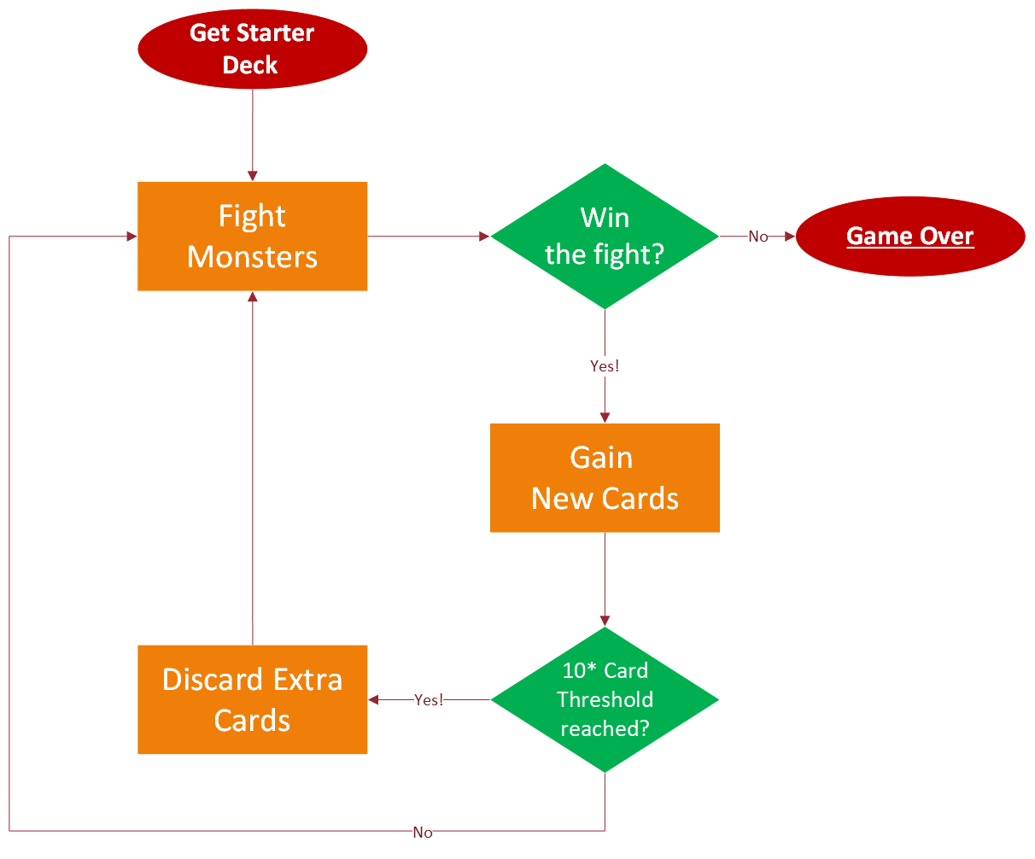

2.2. Combat

2.2.1. Hero Phase:
- Each player (hero) draws 5 cards.
- During their hero phase, the active player can play as many cards from their hand as they want, activating their effects as soon as they are played, unless stated otherwise on the card.
- Played Cards are put into the Discard Pile
- Once an ACT Card is played, the active player redraws 5 cards from their deck.
  - If the active player’s Draw Pile doesn’t have enough cards to get up to 5 hand cards, the cards from their Discard Pile get returned to their Draw Pile.
  - The active player can choose to shuffle the discard pile or to just flip it over.

2.2.1. Enemy Phase:
- Everytime a player ends their turn, all enemies (from left to right) take their action.
- Every enemy has a simple attack with a hit rate and damage value, which work just like the action cards of the heroes.
- All enemies always attack the player that is about to start their turn, damaging them on a hit.
- When all enemies finish their attack, the player that was attacked starts their turn, and the hero-enemy cycle begins anew.
- Once an enemy drops to 0 HP, they are defeated and cannot take a turn anymore.
- When all enemies are defeated, the loot phase starts
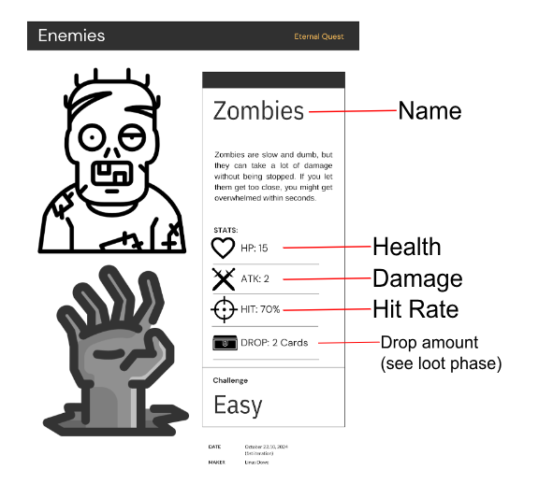

2.2.1. Loot Phase:
- If the players have reached a loot phase, they have defeated all enemies in their current “room”.
- The players now have time to look for loot to improve their hero-deck.
- Each enemy has a “drop amount” on their card. Beginning with the enemy on the left, the players draw as many loot cards as the “drop amount value” of that enemy and place them face up in the middle of the play area (so that both players can easily see them).
- The player who made the final attack on the final enemy starts the looting, chooses one of the cards and adds it to their deck. After that the other player can choose a card and add it to its deck.
- If a player doesn’t want any of the cards, they can instead choose one of them and put it back in the loot draw pile. It will not be replaced by another card meaning that if you put a card back in the loot pile you will also get one loot card less than you could.
- When all loot cards are either taken or added to a deck, the players start looting the next enemy with the same system.
- After all enemies are looted, each player counts the amount of cards in their hero deck. If they now have more than 20 cards in their deck, they need to choose cards to banish.
- To finish the looting phase and prepare for the next room, you shuffle your entire hero deck, draw 5 new cards and draw new enemies. After that, you start anew with a hero phase.

2.2. Cards

2.2.1 Utility cards (UTC Cards)
- These are cards that support a player by healing or buffing them, healing or buffing other players, or debuffing the enemies.
- The cards will (most of the time) not deal damage You can play up to 3 Utility cards per turn, on your or your partner’s field
Balancing Variables:
- Healing
- Temporary HP (Shields, Armor, et cetera)

2.2.1.1. Utility Card Slots
- Each player has 3 “slots” on their field on which Utility cards can be played
- Since every player can play 3 UTC cards on their turn, if a player chooses to play a card for their partner, it will activate at the end of their partner’s turn
  - this fills one of their partner’s slots up until then
- If a player’s own slots are filled before their turn is over, but they still have UTC they can play remaining, they can choose to play those cards on their partner’s field (or end their turn)
- incentivises Team play, as well as strategizing both for yourself and your partner

2.2.2. Action Cards (ACT Cards)
- These are the player’s main way of dealing damage or activating more powerful effects.
- Unlike utility cards, you can't play as many action cards as you want.
- As soon as you play your first action card and apply its effects, your turn ends.
Balancing Variables:
- Hit Rate
- Damage Value
- Special Effects
- Card Type (Martial or Magical)

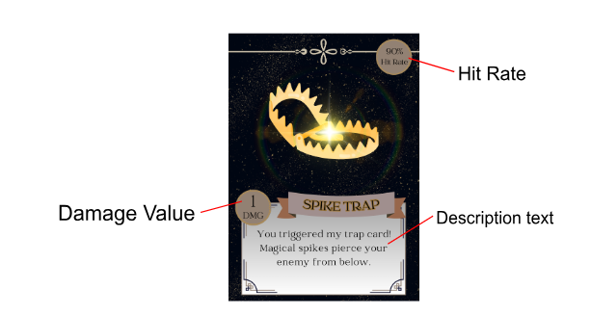

2.4. Proficiencies
- Abilities that diversify the playstyle of each player
- Earned by playing cards of the type correlating to their proficiency
- Passive Bonuses that boost cards of their respective types
- Each proficiency gives a general buff to its respective card type
- A proficiency also replaces specific cards with a special buff, in addition to the general passive buff

2.4.1. Martial
- Earned by playing “Martial” type cards

2.4.2. Magical
- Earned by playing “Magical” type cards

2.4.2. Supporter
- Earned by playing UTL cards for your Ally

2.5. Enemies

2.5.2 . Regular Enemies
- Hostile NPCs that the player’s must face to gain new cards, level up their proficiencies, and progress through the game
- present in each regular room, of each layer, throughout the entire dungeon
- Can either appear alone or in groups of up to 2
  - 1 Enemy (skeleton)
  - 2 Enemies (Max. 1 Skull)
  - 2 Enemies (Max. 1 Skull)
- Drop cards after being defeated, equal to their “drop amount”
  - for further information, see Loot Phase
- Deal consistent damage to the player that takes their turn next in combat after them

2.5.1. Boss Enemies
- A stronger enemy that player’s encounter at the end of a layer of the dungeon
  - currently spawns after 3 Waves of Regular Enemies
  - also currently only one Boss is planned (The Necromancer)
- Drops more cards than a regular enemy
- Defeating them allows the player to fully heal up, edit their deck, and then move on to the next layer of the dungeon (TBA)
Balancing Variables:
- Drop Amount (Cards)
- HP
- Damage

2.6. Level Design
- The game is set in a Dungeon, which consists of multiple layers, which in turn consist of multiple waves of enemies

2.6.1. Waves
- A wave brings new enemies for players to face
- The first wave starts with 1 enemy, each following wave with 2
- After defeating the enemies, they gain new cards, edit their deck and move on to the wave
- As of right now, after clearing multiple waves, the players will face the dungeon’s boss enemy, which they have to defeat in order to beat the dungeon and win the game

2.6.2. Layers (TBA)
- A layer consists of multiple rooms which the players have to clear
- Each layer has a single boss room, which is found at the end of each layer
- Every procedural layer has more difficult enemies and in turn stronger cards to be looted
- There are multiple layers in the dungeon
- Currently, 1 layer is implemented and balanced around

2.6.3. Dungeon
- The place the game is set in
- After clearing each and every wave, in each and every layer, the players will face the final boss of our game, found at the very end of the final layer (TBA)

2.7. Narrative
- The game is set as a meta narrative, the player’s being adventurers in a tavern playing a card game
- The card game itself is based on going adventuring in a dungeon, defeating enemies and by doing so earning skills (Proficiencies) along the way
- As adventuring is a team based effort, you always need one friend to play the game with you so you can rely on each other along the way, strategizing to effectively take down your foes together
- Since adventuring is a very lucrative career path (if you forget about its mortal dangers), the looting is represented by the cards you receive after defeating your foes
- But most importantly, the game both in- and outside of the meta narrative is supposed to be a low-stakes and fun game to play and experience with your friends

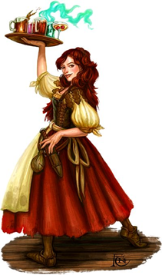
Reference Image https://uk.pinterest.com/pin/312859505361949118/

2.7.1. Narrator
General Info:
- Name: Leandra, Lea’
- Tavern Owner and Bartender
- Middle-aged Woman
- Maternal, a very motherly figure
- Has a very cheeky, tongue-in-cheek humour
- Loves Fun, and entertaining her guests
Wants:
- Wants to entertain her guests
- Make her Tavern a warm and welcoming environment
- Have a fun time with her guests, both when serving booze and when playing the game
Needs:
- A fun and relaxed environment
- Her Tavern to be a successful business

Backstory:
- The stories of Dragons, Dungeons, Gold, Monsters, and Adventure she heard about by meeting and talking to her fair share of adventurers inspired her to create a game based on adventuring
- It all sounded so very exciting to her, so she used these stories she got told and the things she learned from them to create something akin to them the every-person could experience
- Since she made the game herself, she knows the card game very well, more than enough to be the Game Master, and to take over the role of running the game for her patrons
- She commissioned a friend of hers in her village, a woodworker by profession.
- They are the person responsible for making the cards themselves, acquiring the materials and using their tools to burn the cards into them
- And since she is the Game Master, she is also the one voicing the game, explaining the rules, and giving the game her flair, all of which the player will experience through voicelines

3. Interface

3.1. Controls
- Mainly controlled by Mouse (& Keyboard)
- Drag and Drop, or Double Click for card placing

3.2. UI/UX
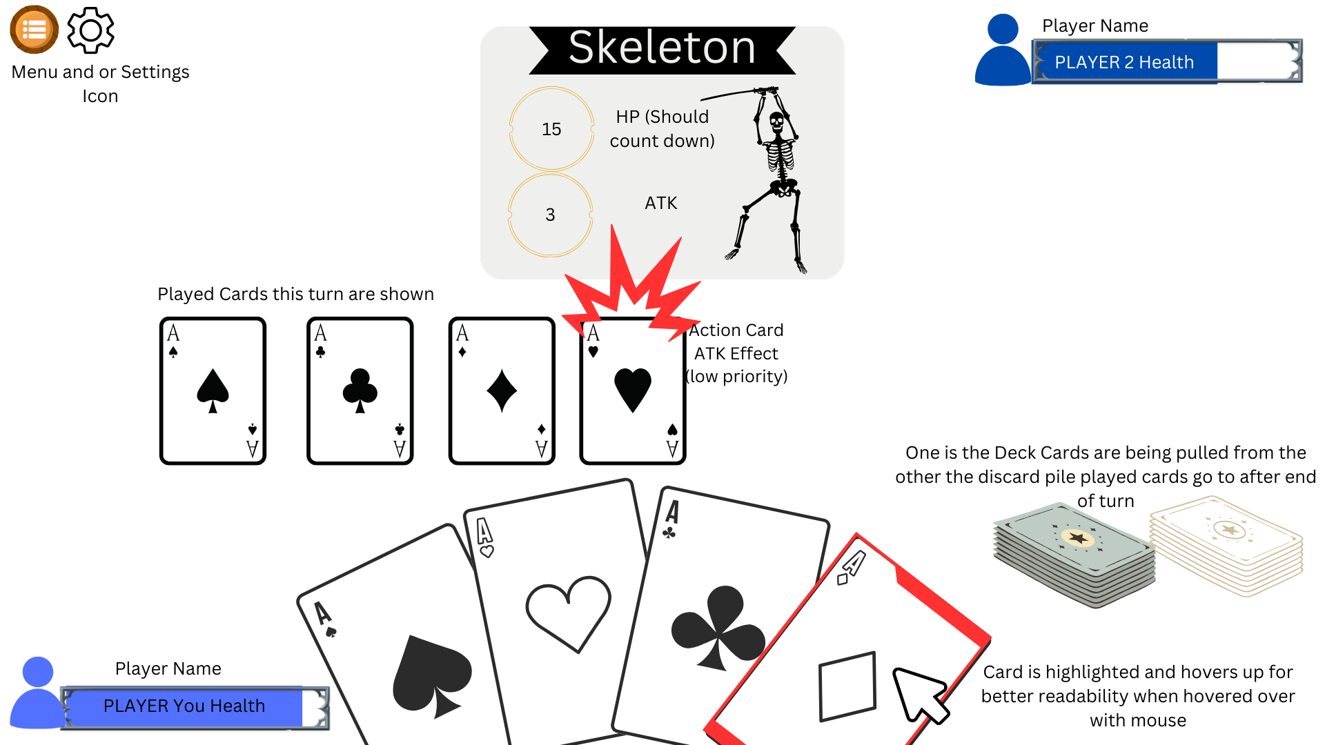

3.3. Menus

3.3.1. Start Menu

3.3.2. Settings Menu

3.3.3. HUD

3.3.4. Credits

4. Art Direction

4.1. Design

4.1.1. Artstyle
- Soldered Wood
- Cards are made out of wood, and burnt into it
- 2D

4.1.3. Character designs
- The Enemies are based on the commonfolk’s perception of monsters
- And the cards are based on the imagination of a common person, envisioning themselves in the shoes of adventurers

4.1.4. Background
- A tavern table is the location our game is played on in the narrative, and it will serve as the background of our game while playing

4.2. Visual Effects (VFX)

4.3. Lighting

4.4. Animation

5. Audio

5.1. Music
- Medieval Music?
- Fantasy Tavern Ambience?
- Fantasy Bard Music?
- Medieval Bards?

5.2. SFX
- Wood on Wood sounds for card placement
- Possible Effect Sounds as cards take effect?

5.3. Voice Acting
- The Narrator, Leandra, will be voice acted by a professional Voice Over Artist, Sarah Doreen MacPhee
- Leandra will narrate the game, the enemies, the effects, much like a game master in table-top roleplaying games
- She will also explain the rules, and how to play the game
- Leandra will serve as the main immersion, as her voice will give meaning to the meta-narrative and game as a whole

