Game Design Document
(GDD)

111 424 111

Table of Contents
Contents
Table of Contents 2
1. Game Overview 4
1.1. Game Concept 4
1.2. Game loop 4
1.3. Vision Statement 5
2. Mechanics 5
2.1. Gameplay 5
2.2. Abilities 6
3. Level Design 7
3.1. Macro Level Design 7
3.2. “Islands” 7
4. Narrative 8
4.1. Player Character 8
4.2. Non-Player Characters 8
4.3. Plot 9
4.4. Days 10
5. Interface 11
5.1. Controls 11
5.2. Music, sound effects, audio 11
5.3. UI 11
5.3.1. Start Menu 11
5.3.2. Settings Menu 11
5.3.3. HUD 11
5.3.4. Credits 11
6. Technical 11
6.1. Target Hardware: 11
6.2. Engine: 11
7. Art 11

1. Game Overview

1.1. Game Concept
- 3D Dream-core Metroid-vania
- The player characters hands change their appearance, and along with that their abilities
- They gain these mechanics by finding them and completing an event to have access to them for the remainder of the Game
- Use those abilities to progress through the levels to get to your goal
- The Goal: Wake Up!
- The Player has 3 days to achieve their goal, and to explore the game before the Ending, but those 3 days will “loop” giving the player as much time as they need
- You must play the game multiple times to explore it in its entirety

1.2. Game loop
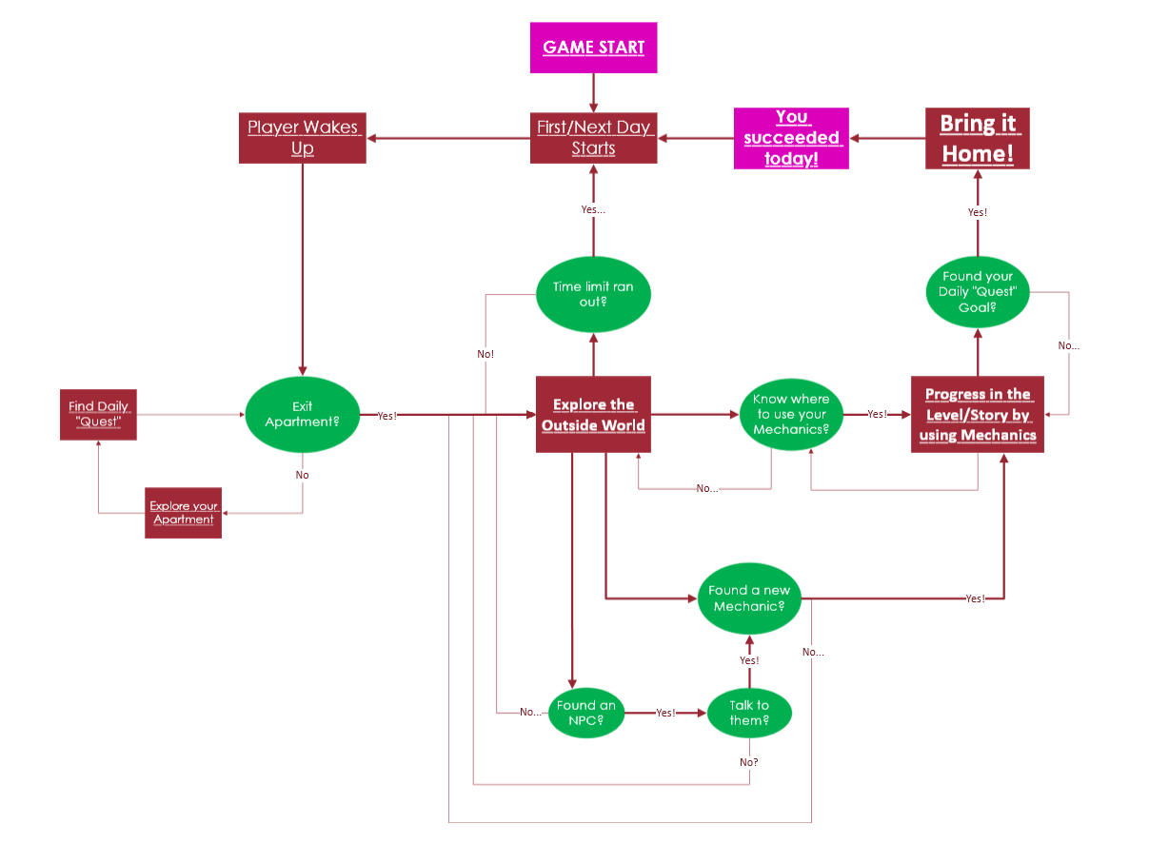

1.3. Vision Statement
What is the first question anyone asks themselves once they think about fiction?
Well, usually its “the Main character has been dreaming the entire story”.
With our Game, we want to ask the follow up question:
Why are they dreaming? What are they dreaming about? Who do the other characters in the dream represent?
111 424 111 is therefore a story set within a dream, about the dream, and everything it represents.

2. Mechanics

2.1. Gameplay
2.1.1. Time
The Game will work with a System of Days, of which there are 3 total.
Once the time of a Day runs out, the PC will fall asleep within the dream and wake up at home again, upon which the second Day starts.
After the third day, regardless of whether or not the Player managed to complete all their “Objectives”, the PC falls asleep again, and will wake up on the 1st Day again.
This will repeat until the player manages to reach the Final Level by gathering all required MacGuffins.
At that point the time will “break” and the player will have the opportunity to either go back to the loop, or to finish the game and win.

2.1.2. Sanity
Any time the Player encounters anything that breaks reality, too much for a normal person to handle it, their Sanity meter decreases.
This can be a fearsome monster, a Dialogue that is maddening, or even finding one of the MacGuffins.
If the player’s Sanity bar reaches zero at any point during gameplay, their mind breaks, they fall unconscious, and the Day ends.

2.1.3. “MacGuffins”
The Objects that the player needs to collect in order to finish the Game.
The first 3 Main MacGuffins are the objects the player is told to find every day.
These will grant them enhanced versions of each ability (More Speed/Jump height for Physical, More Interactions for Astral, More Objects for Telekinesis).

Beyond them however, there will be a bunch of “secret” MacGuffins spread throughout each Level.
Finding one of them will decrease Sanity, but through their descriptions offer a new piece of the big puzzle that is the game's story.
You can either find them lying on the ground, hidden behind more advanced puzzles, or get them by talking to specific NPCs.
Upon finding all of them, the pathway to the Final Level will unlock, and the player will be able to then Finish and Win the game, choosing to either stay in the dream, or WAKE UP.

2.2. Abilities
2.2.1. Enhanced Physicality
- Enhanced Speed
- Double Jump
- Works with an Endurance meter
- Jump N’ Run style puzzles
- Associated Color: RED

2.2.2. Astral Projection
- Being able to phase through walls
- Talking to creatures and buildings that are usually hidden/you are unable to talk to normally
- Labyrinths with Hidden Pathways/Doors
- Associated Color: GREEN

2.2.3. Telekinesis
- Pulling specific Objects to them from a distance
- Pushing specific held objects away from them
- Object based Puzzles, Portal-esque
- Associated Color: BLUE

3. Level Design

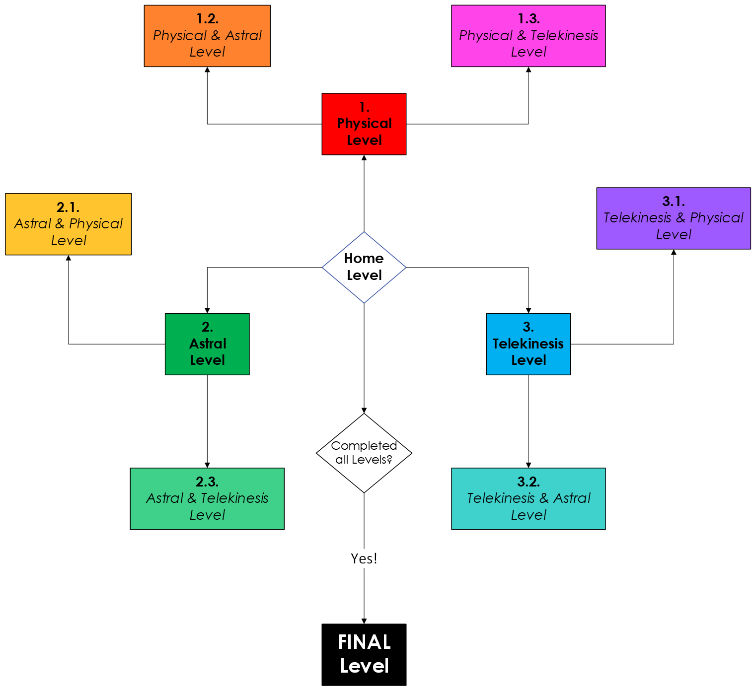
3.1. Macro Level Design

3.2. “Islands”
Each of these levels are separate islands, which will be “visible” from our home level.
Every island has mechanics that are associated with it, that you will be able to use to solve puzzles which can be found on them.
For example, the first level is the physical level. By using your enhanced speed and double jump, you are able to complete a Jump N’ Run puzzle in order to get to your daily objective and complete the “Day” properly.
From this level, you will also be able to travel to the levels that combine multiple abilities, in this instance “Physical and Astral” and “Physical and Telekinesis.”
This unlocks starting with the second “Loop” of our game, and both Astral Projection and Telekinesis have levels of their own of course.

4. Narrative

4.1. Player Character
Since the game will take place in an extended dream sequence, the PC will be two distinct characters, the dream version being based on the hidden story of the reality version.
The Dream sequence will also be presented as an extension of the PC’s reality, which is amplified through the absurdity of their subconscious mind.

4.1.1. Dream version:
- Blank Slate
- Takes on the colours of the abilities they acquire
- Has no real idea where they are, and what they are trying to accomplish
- Will explore these questions through exploring the Game
- Trying to piece together what is going on and what happened to put them into this place

4.1.2. Reality Version:
- Somnology Student at the tail end of studying their degree
- They are suffering from extreme Insomnia
- Before the events of the game, they were awake for 100+ hours
- Staying awake for that long caused their brain to short circuit and induce a coma-esque state
- The dream sequence is where their subconscious places them into
- All their thoughts and emotions during this period are what creates the landscape and characters they encounter in the dream

4.2. Non-Player Characters
- Personifications of their fears, hopes, and other impactful things or situations they envisioned during their state of Insomnia
  - Meaning that their appearance can vary widely from fantastical to the mundane
- These can vary vastly between positive and negative attitudes towards the PC
- You will interact with them (and thus ideally piece together the story of the game) through dialogue
4.2.1. Distractions
- Some of the characters they encounter will serve as distractions for the player to get lost in via immersion
- Since the game will have a time limit for each day (the total being 3 days), if the player chooses to engage with them to much, they lose themselves in the dream and won’t be able to reach the resolution in time
  - At which point the game starts over, and they go back to the beginning of the dream
  - This allows the player to seek out things that are relevant to the overarching narrative, if they so choose

4.3. Plot
The Game’s story starts from the endpoint of the experience the Reality PC went through, as the player must piece together the information, which they receive by exploring the game and talking to the things, creatures, beings and people they encounter.
They start out knowing nothing about the situation they find themselves in, much like the player, and will have to figure this out as they go along.
Each step they take is a new piece of information that will lead them to the conclusion of the puzzle-like structure of the narrative.


The first half of said conclusion is the dream version of the PC realising that they are dreaming.
To reach the true conclusion however, that being waking up, they will have to learn what caused this endless dream to happen and figure out how to fix that problem, which will be done by dealing with their reality, fixing their personal issues, confronting the struggles and mental health issues that caused them, instead of avoiding it by continuing to live in the fantasy of the dreamland.

4.4. Days
4.4.1. Day 1:
- The Player Character wakes up in their apartment
- You get the first simple “quest”
- The player leaves their apartment and enters the world (level)
- They explore the level trying to find the solution to the quest
- Throughout the day, they meet various different interesting NPCs
- They will have the opportunity to explore the level.
- The day either ends when they complete the quest
- (or when the time of the day is over. ) TBA.

4.4.2. Day 2: TBA.

4.4.3. Day 3: TBA.

5. Interface

5.1. Controls: Mouse & Keyboard

5.2. Music, sound effects, audio

5.3. UI

Start Menu

Settings Menu

HUD
  - Sanity Bar
  - Time
  - Endurance Meter
- Credits

6. Technical

6.1. Target Hardware: PC

6.2. Engine: Unreal Engine 5.5.4.

7. Art
- 3D low-poly dream-core
- Liminal Spaces
- “Weird Guys” as NPCs
- Progressively more unnerving with each day of the game
- Intentional Style Clashes all over the place, to break “reality” so to speak

