Eternal Quest Narrator

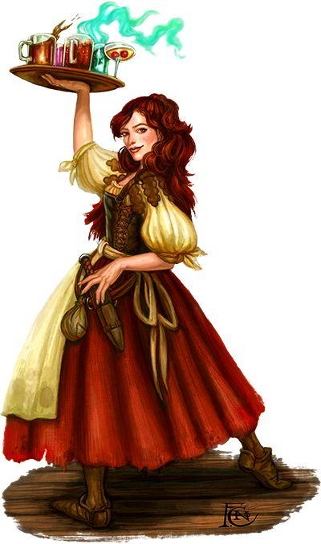
General Info:
- Name: Leandra, Lea’
- Tavern Owner and Bartender
- Middle-aged Woman
- Maternal, a very motherly figure
- Has a very cheeky, tongue-in-cheek humour
- Loves Fun, and entertaining her guests
Wants:
- Wants to entertain her guests
- Make her Tavern a warm and welcoming
environment
- Have a fun time with her guests, both when
serving booze and when playing the game
Needs:
- A fun and relaxed environment
- Her Tavern to be a successful business

Backstory:
- The stories of Dragons, Dungeons, Gold, Monsters, and Adventure she heard about by meeting and talking to her fair share of adventurers inspired her to create a game based on adventuring
- It all sounded so very exciting to her, so she used these stories she got told and the things she learned from them to create something akin to them the every-person could experience
- Since she made the game herself, she knows the card game very well, more than enough to be the Game Master, and to take over the role of running the game for her patrons
- She commissioned a friend of hers in her village, a woodworker by profession.
- They are the person responsible for making the cards themselves, acquiring the materials and using their tools to burn the cards into them
- And since she is the Game Master, she is also the one voicing the game, explaining the rules, and giving the game her flair, all of which the player will experience through voicelines

